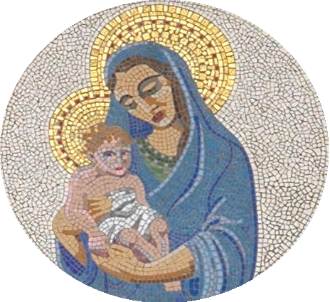

Permission for photographs

We are continually updating our school website and provide a weekly newsletter. We like to include a variety of photographs taken of events and class activities in both. In keeping with Child Protection and GDPR regulations, legally, the school requires permission in order to use photographs that might include your child.

From time to time, we also use photographs of the children in the local press, in promotional material and displays. We also keep some photographs for historical purposes. As per GDPR regulations, we also require your consent to allow these photographs to be stored, used and shared, even when your child has left the school.

Many thanks for your support.

Please complete the following and return:

Child’s name: ...............................................................................................................................

I give consent / do not give consent for my child to have their photograph used in the school newsletter, on the school website or in other displays and school promotional material. I understand that all photographs will not include full names or specific details of my child. I give consent for photographs to be stored and possibly used even after my child has left Cottesmore St Mary.

Signed: ....................................................................................... Parent / Carer

Print name: ............................................................. Date: ......................................

