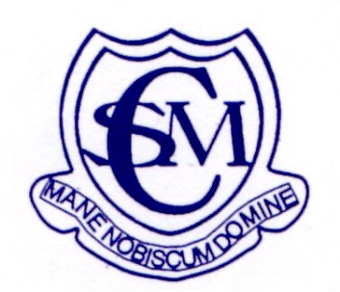
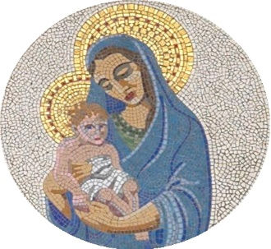
Welcome to
Cottesmore St Mary Catholic Primary School

All about me!

Please stick a photo
of yourself here

My first name is __________________________

My surname is____________________________

I like to be called ________________________

I was born on ___________________________

Draw a picture of all the people who live in your house.

Other special adults in my life are__________________________

When I am not in school I like to play with ______________________

The language I speak at home is ____________________________

I can also speak ________________________________________

I celebrate these festivals at home_________________________

Things I enjoy doing the most.

Things that I least enjoy.

When I start school I am looking forward to

Things that I might be worried about.

Looking After Myself

(Please circle)

I can put my coat on. Yes Nearly Not yet

I can do up buttons. Yes Nearly Not yet

I can do up zips. Yes Nearly Not yet

I can blow my own nose. Yes Nearly Not yet

I can look after myself
in the toilet. Yes Nearly Not yet

I can wash my hands. Yes Nearly Not yet

I can dress myself. Yes Nearly Not yet

I can put my shoes on. Yes Nearly Not yet

I can use a knife and fork. Yes Nearly Not yet

I can cut with scissors. Yes Nearly Not yet

I can recognise my name. Yes Nearly Not yet

I can write my name. Yes Nearly Not yet

Have a go at writing your name here

About your child

As a parent, you know your child better that anyone and we ask you to share the following information to aid us in making their transition as smooth as possible.

Does your child enjoy playgroup or nursery? Did they find any aspects of nursery a challenge?

Does your child find it difficult to leave you?

Do they make friends easily?

Do they particularly like or dislike any activity?

Do you want to make any comments about your child‛s readiness for
school?

Are there any special family circumstances or events you would like us
to know about? Such as a new baby, illness in the family, or other changes?

Does your child have any allergies or medical needs that you need make us aware of?

Is there anything else you would like us to know?

